ITL NDR
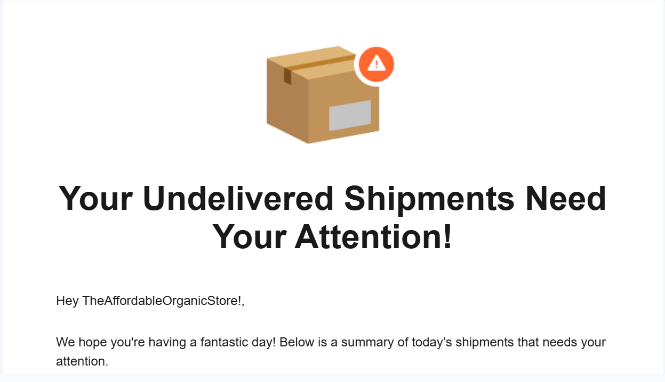
STEP -1:
Download the excel sheet from the mail.
STEP -2:
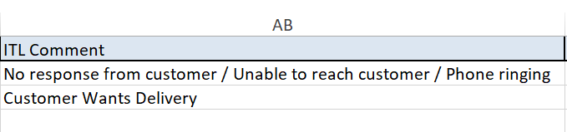
In ITL comments, wherever there is customer wants delivery written, copy the AWB no.s and mail them back saying to do reattempt.

STEP – 3:
For other scenarios, check all the remarks. For address incomplete, take the AWB no. and go to superapp. Go to eye icon of action and check whether address is correct or missing something.
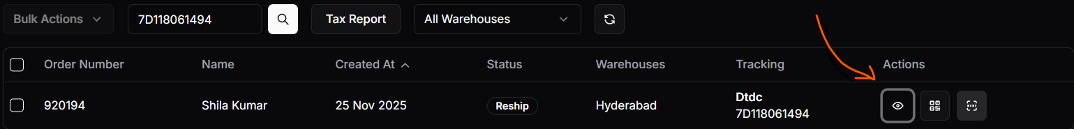
Address should contain house or colony number, road no., landmark, district, pincode. Check whether phone number contains 10 digit or not. If not (rare case), mail to customer from info@theaffordableorganicstore.com .
STEP – 4:
If everything is correct, tell them to reattempt. If address is wrong, call the customer and ask for the updated address and forward it to whatsapp group tagging the AWB no. If address and phone number both are correct, then delivery must happen. Ask in the whatsapp group why it did not happen. Tell to reattempt in mail.
STEP – 5:
Any other cases, if reason is not so familiar, forward the AWB no. to the ITL whatsapp group. Where issues are sorted, mail those numbers to ITL saying to do reattempt.
STEP – 6:
Create another column named “my comments” at the excel sheet, where the person has to write what he has done. Sample formats are provided below –
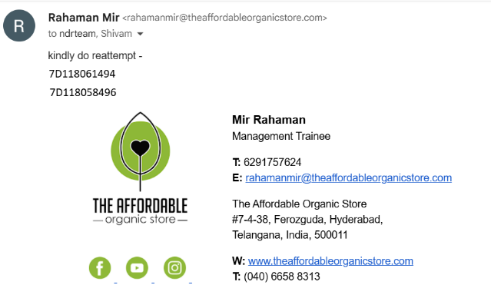
**Reply this NDR mail within next 24hrs.**
Another type of mail that comes daily, previous one does not come daily-
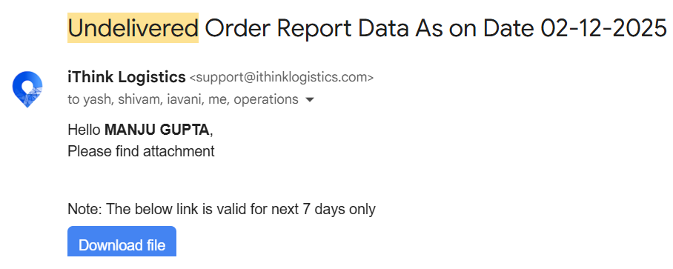
This is valid till next 7 days. Try to solve this in the same way.

